July 16, 2020

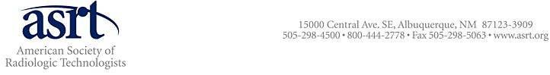
The Honorable John Bel Edwards
Governor of Louisiana
Baton Rouge, LA 70821-0201

Dear Governor Edwards,

The American Society of Radiologic Technologists (ASRT) is the national professional association representing more than 2,300 medical imaging and radiation therapy professionals who work in Louisiana hospitals, cancer treatment centers, diagnostic imaging centers and urgent care clinics providing direct patient care. Radiologic technologists are responsible for performing imaging examinations on COVID-19 patients on a daily basis, coming into close, personal contact with patients with Coronavirus. Radiologic technologists also perform x-ray and other imaging examinations on patients who are intubated and in the COVID-19 intensive care units. The Louisiana Society of Radiologic Technologists is a valued ASRT affiliate society.

ASRT wishes to express its disappointment that radiologic technologists and radiation therapists were not included in one-time $250 tax rebate program for essential workers. For cancer patients, radiation therapists must treat patients receiving curative radiation therapy regardless of their COVID-19 status. Medical imaging examinations must be completed on patients regardless of their COVID-19 status. Radiologic technologists and radiation therapists are deemed as essential workers in the Cybersecurity and Infrastructure Security Agency’s publication “Guidance on the Essential Critical infrastructure Workforce: Ensuring Community and National Resilience in COVID-19 Response Version 3.1” along with many other health care professions who provide direct care to patients with coronavirus. These professions include physical therapists, physical therapy assistants, speech-language-hearing pathologists and speech pathology assistants. Providing the tax rebate only to the professions listed on the Department of Revenue’s website is inequitable and potentially divisive to the entire team of health care workers who provide direct patient care to COVID-19 patients.

ASRT does not agree with the Department’s exclusion of certain health care professions that are included in the CISA guidance document and respectfully requests that radiologic technologists and radiation therapists be included as essential workers eligible to receive the $250 tax rebate. ASRT requests that an executive order adding “radiologic technologists and radiation therapist” to the emergency rule published on July 13 be issued by the Office of the Governor.

If you have any questions regarding ASRT’s position on this issue, please contact Deputy CEO Greg Morrison (gmorrison@asrt.org) or Vice President of Government Relations Christine Lung (cjlung@asrt.org). We look forward to working with the State of Louisiana to ensure that all essential health care workers receive fair benefits and treatment as they work to place COVID-19 patients on the path to recovery.

Sincerely,
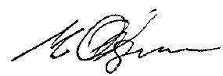

Michael Odgren, B.S., R.P.A., R.R.A., R.T.(R)(CT)
ASRT President

Cc: The Honorable Sam L. Jenkins, Jr.
The Honorable Clay Schexnayder, Speaker of the House
Senator Patrick Page Cortez, Senate President
Alyssa Bell, B.S., R.T.(R), President, Louisiana Society of Radiologic Technologists

